**Create the below tables with appropriate data types and constraints. Then Solve the queries.**

**Note : The queries and its output needs to be saved and pushed to the git link**

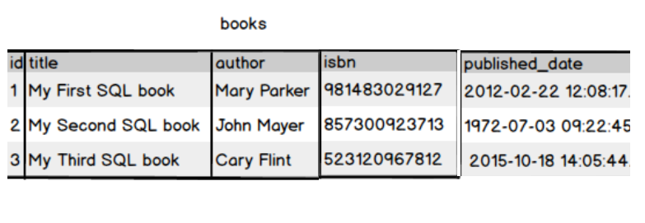

Create a book table with id as primary key and provide the appropriate data type to other attributes .isbn no should be unique for each book

Write a query to fetch the details of the books written by author whose name ends with er.



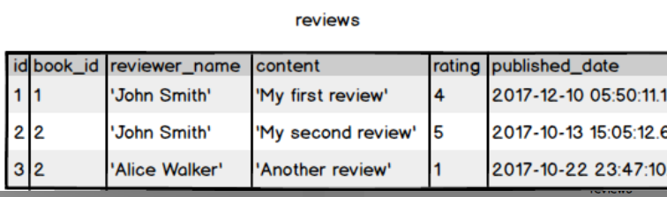

Display the Title ,Author and ReviewerName for all the books from the above table





Display the reviewer name who reviewed more than one book.

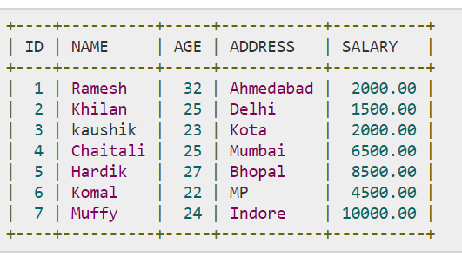

Display the Name for the customer from above customer table who live in same address which has character o anywhere in address

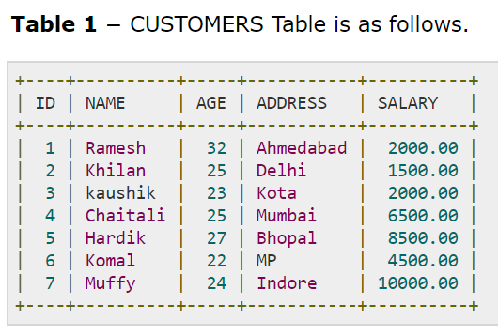 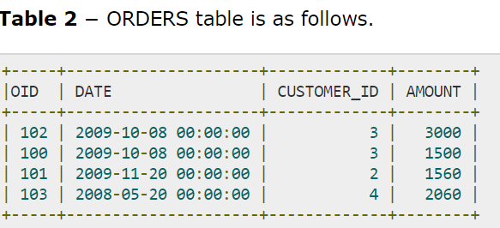

Write a query to display the Date,Total no of customer placed order on same Date

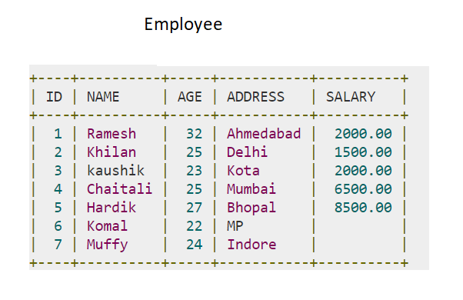

Display the Names of the Employee in lower case, whose salary is null

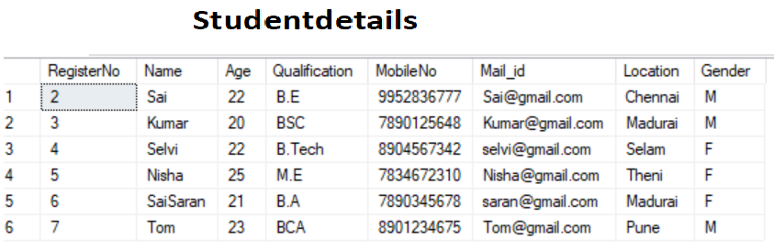

Write a sql server query to display the Gender,Total no of male and female from the above

relation .

**HTML**

Q 1

The below is the document which needs to be corrected

Dihydrogen Monoxide Dihydrogen monoxide, also known as hydroxyl acid or DHMO1, is a dangerous substance that2: is the major component of acid rain, contributes to the greenhouse effect, may cause severe burns, is fatal if inhaled, contributes to the erosion of our natural landscape, accelerates corrosion and rusting of many metals, may cause electrical failures and decreased effectiveness of automobile brakes, and has been found in excised tumors of terminal cancer patients. Despite the danger, DHMO is often used: as an industrial solvent and coolant, in nuclear power plants in the production of StyrofoamTM, as a fire retardant, in many forms of cruel animal research, as an additive in certain junk-foods and other food products, in the distribution of pesticides. Even after washing, produce remains contaminated by this chemical. 1The more common chemical formula is H2O. 2Source: Coalition to Ban Dihydrogen Monoxide.

The changes you want to make are:

1. The page should have the title (changes the tab name) Dangers of DHMO.

2. Mark the first line with the tags for the biggest heading.

3. Give the next two words a strong (bold) appearance.

4. Emphasize (italicize) the first occurence of hydroxyl acid and DHMO

5. All numbers except the 2 in H2O should be superscripted like this : 1 .

6. Mark the letters TM behind Styrofoam as superscript.

7. The 2 in H2O should be subscripted.

8. Put paragraph tags around the different paragraphs of the article

9. If you would like to keep the original spacing on the lists, you will want to use break tags after each comma

Q 2

For this exercise, you will make an ordered list of unordered lists. The example topic will be a multi-stop shopping trip.

Suggested steps:

Create all of the ordered list tags first. One ol tag at the top and bottom, with three sets of li tags. The three list items could be groceries, hardware, and electronics

Under each list item, but before the closing li tag, create an unordered list. Each of the three unordered lists needs to be within the li tags of the ordered list.

The items for them could be:

Apples, oranges, bananas

Hammer, nails, duct tape

Earphones, Movies, Fan